### 

### Semester One Examination, 2018

### Question/Answer booklet

# MATHEMATICS

**UNIT**

## Section One:

## Calculator-free

Your Name

Your Teacher’s Name

## Time allowed for this section

Reading time before commencing work: five minutes

Working time: fifty minutes

## Materials required/recommended for this section

***To be provided by the supervisor***

This Question/Answer booklet

Formula sheet

***To be provided by the candidate***

Standard items: pens (blue/black preferred), pencils (including coloured), sharpener, correction fluid/tape, eraser, ruler, highlighters

Special items: nil

## Important note to candidates

No other items may be taken into the examination room. It is **your** responsibility to ensure that you do not have any unauthorised material. If you have any unauthorised material with you, hand it to the supervisor **before** reading any further.

| Question | Mark |  | Question | Mark |  |
| --- | --- | --- | --- | --- | --- |
| 1 |  | 7 | 4 |  | 8 |
| 2 |  | 5 | 5 |  | 7 |
| 3 |  | 11 | 6 |  | 12 |

**Structure of this paper**

| Section | Number of questions available | Number of questions to be answered | Working time (minutes) | Marks available | Percentage of examination |
| --- | --- | --- | --- | --- | --- |
| Section One:  Calculator-free | 6 | 6 | 50 | 50 | 35 |
| Section Two:  Calculator-assumed | 12 | 12 | 100 | 100 | 65 |
|  |  |  |  | **Total** | 100 |

**Instructions to Candidates**

1. The rules for the conduct of the Western Australian Certificate of Education ATAR course examinations are detailed in the *Year 12 Information Handbook 2018.* Sitting this examination implies that you agree to abide by these rules.
2. Write your answer in this Question/Answer booklet.
3. You must be careful to confine your answers to the specific questions asked and to follow any instructions that are particular to a specific question.
4. Additional pages for the use of planning your answer or continuing your answer to a question have been provided at the end of this Question /Answer booklet.If you use the space to continue an answer , indicate in the original answer space where the answer is continued.
5. **Show all your working clearly.** Your working should be in sufficient detail to allow your answers to be checked readily and for marks to be awarded for reasoning. Incorrect answers give without supporting reasons cannot be allocated any marks. For any question or part question worth more than two marks, valid working or justifiation is required to receive full marks. If you repeat any question , ensure that you cancel the answer you do not wish to be marked.
6. It is recommended that **YOU DO NOT USE PENCIL**, except in diagrams.
7. The Formula Sheet IS NOT to be handed in with your Question/Answer booklet.

**Section One: Calculator-free (50 Marks)**

This section has **six (6)** questions. Answer **all** questions. Write your answers in the spaces provided.

Spare pages are included at the end of this booklet. They can be used for planning your responses and/or as additional space if required to continue an answer.

● Planning: If you use the spare pages for planning, indicate this clearly at the top of the page.

● Continuing an answer: If you need to use the space to continue an answer, indicate in the original answer space where the answer is continued, i.e. give the page number. Fill in the number of the question that you are continuing to answer at the top of the page.

Working time: 50 minutes.

**Question 1**

**(7 marks)**

Solve the following equations for $x$

(a) $\frac{3x}{2}=\frac{7}{5}$ (1 mark)

(b) $\frac{2x+6}{5}-\frac{x-3}{4}=2$ (3 marks)

(c) $x^{3}-2x^{2}-3x=0$ (3 marks)

**Question 2 (5 marks)**

Consider the points *A*(3, -5) and *B*(-1, -2).

(a) If *B* is the midpoint of *A* and *C*, determine the coordinates of *C*. (2 marks)

(b) Determine the equation of the line through *A* that is perpendicular to *AB*. (3 marks)

**Question 3 (11 marks)**

Consider the polynomial $P\left(x\right)=2x^{3}-12x^{2}+22x-12$

(a) State the degree of $P(x)$ (1 marks)

(b) Show that $P(x)$ has an x intercept at $(3,0)$ (2 marks)

(c) Show that $x-1$ is a factor of $P(x)$ (2 marks)

(d) State $P(x)$ in **FULLY** factorized form (3 marks)

(e) State all solutions to $P\left(x\right)=0$ (3 marks)

**Question 4 (8 marks)**

Given that , and ,

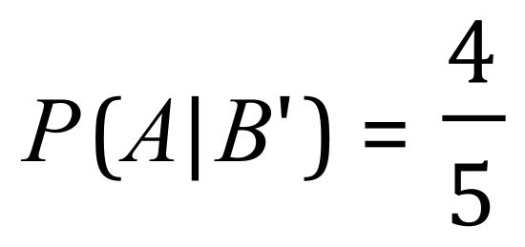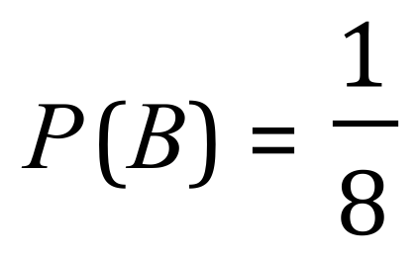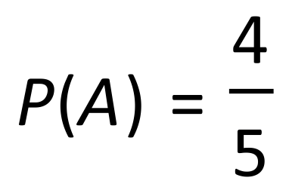

1. find (3 marks)

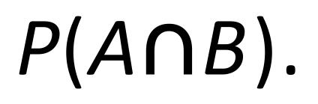

1. find (3 marks)

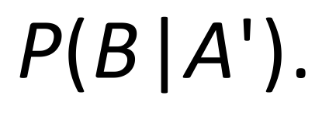

1. State, with a reason, whether *A* and *B* are independent events. (2 marks)

**Question 5 (7 marks)**

1. Find the point of intersection of: (4 marks)

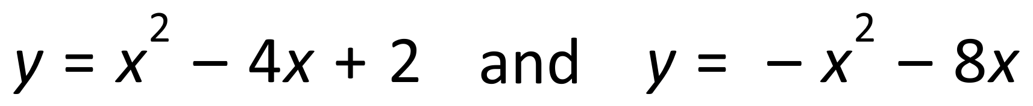

(b) Solve . (3 marks)

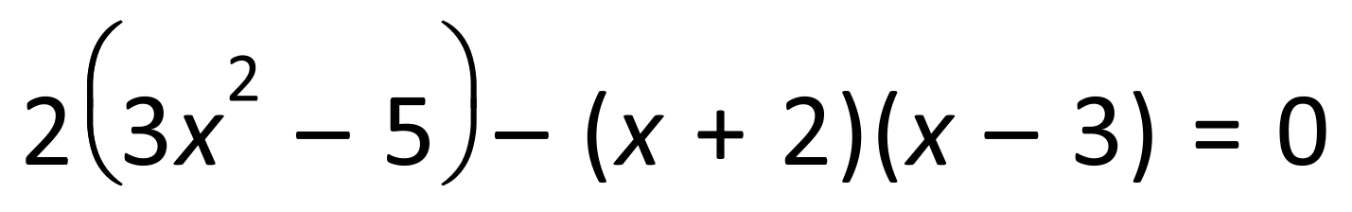

**Question 6 (12 marks)**

1. Sketch graph of *y* = – 2, labelling all special features. (5 marks)

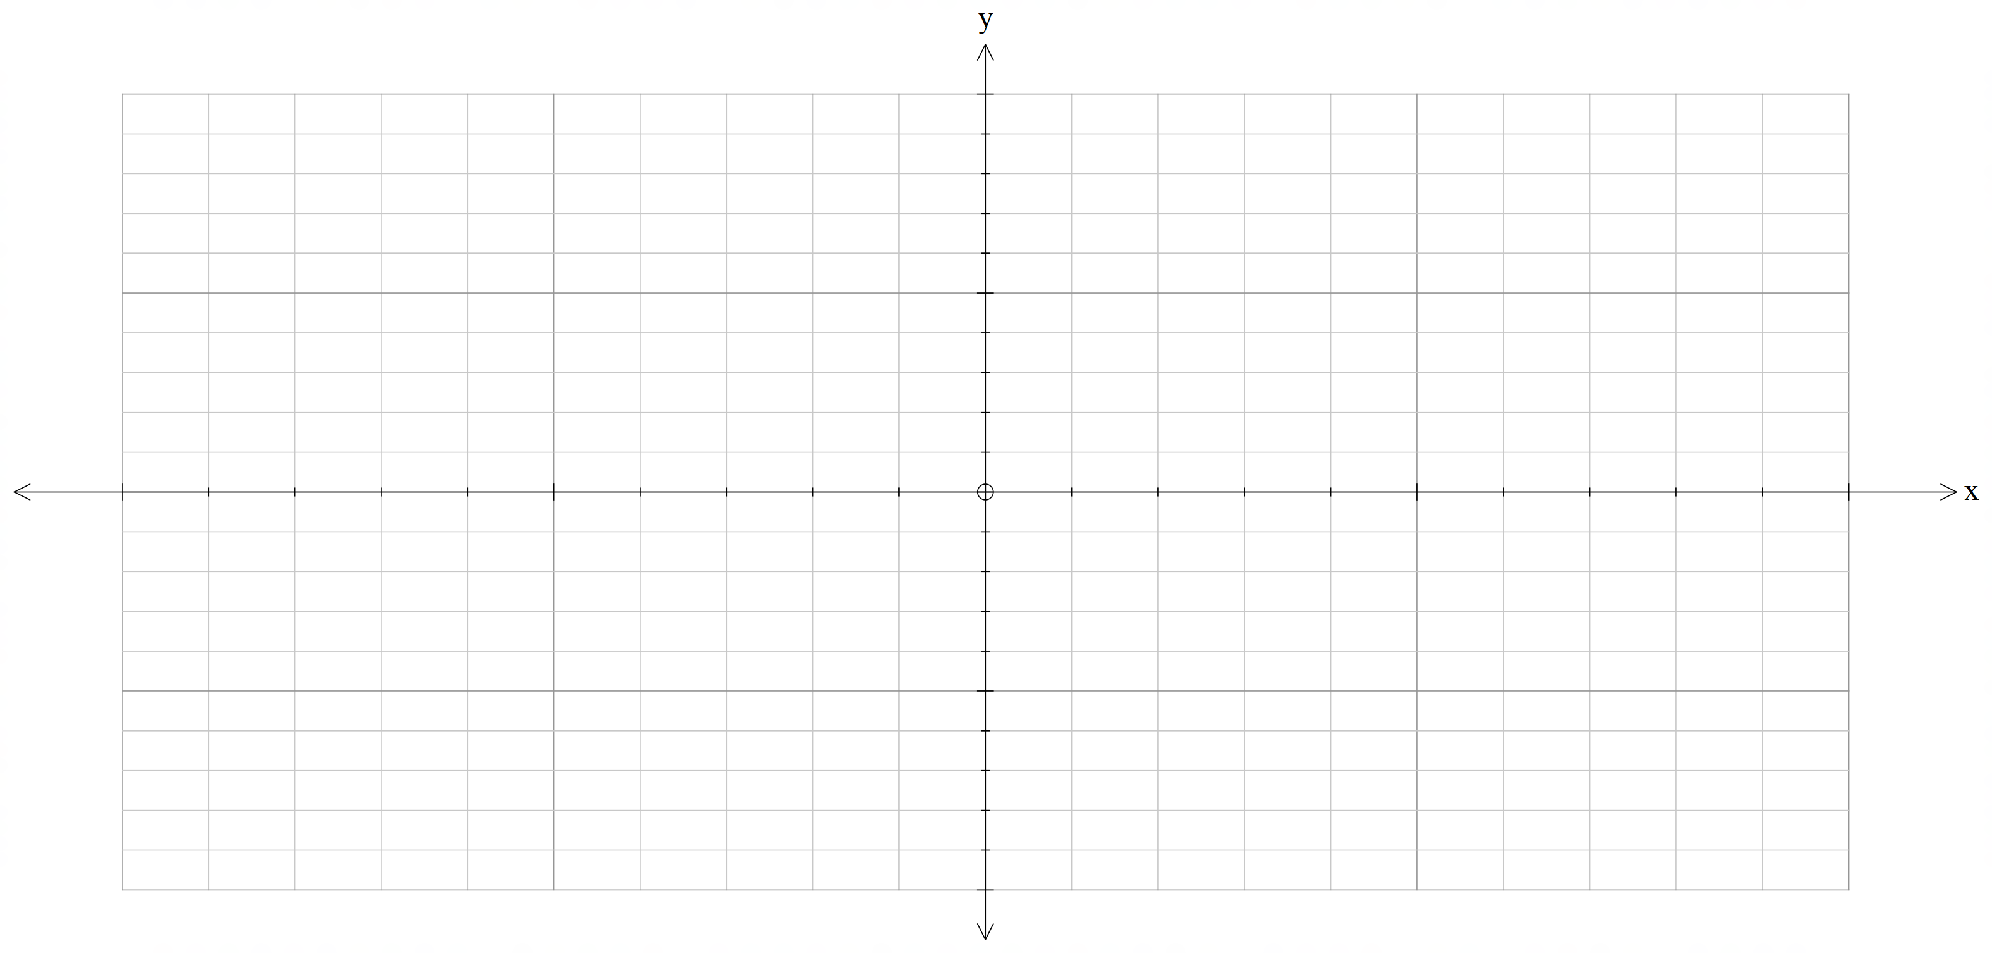

b) i. Express *x*2 – 2*x* + *y*2 + 4*y* – 4 = 0 in the form (*x* – *h*)2 + (*y* – *k*)2 = *r*2 (7 marks)

# ii. Hence sketch the graph of the circle. Label all intercepts with the axes.



**Additional working space**

Question number:

**Additional working space**

Question number:

**Additional working space**

Question number:

**Additional working space**

Question number: